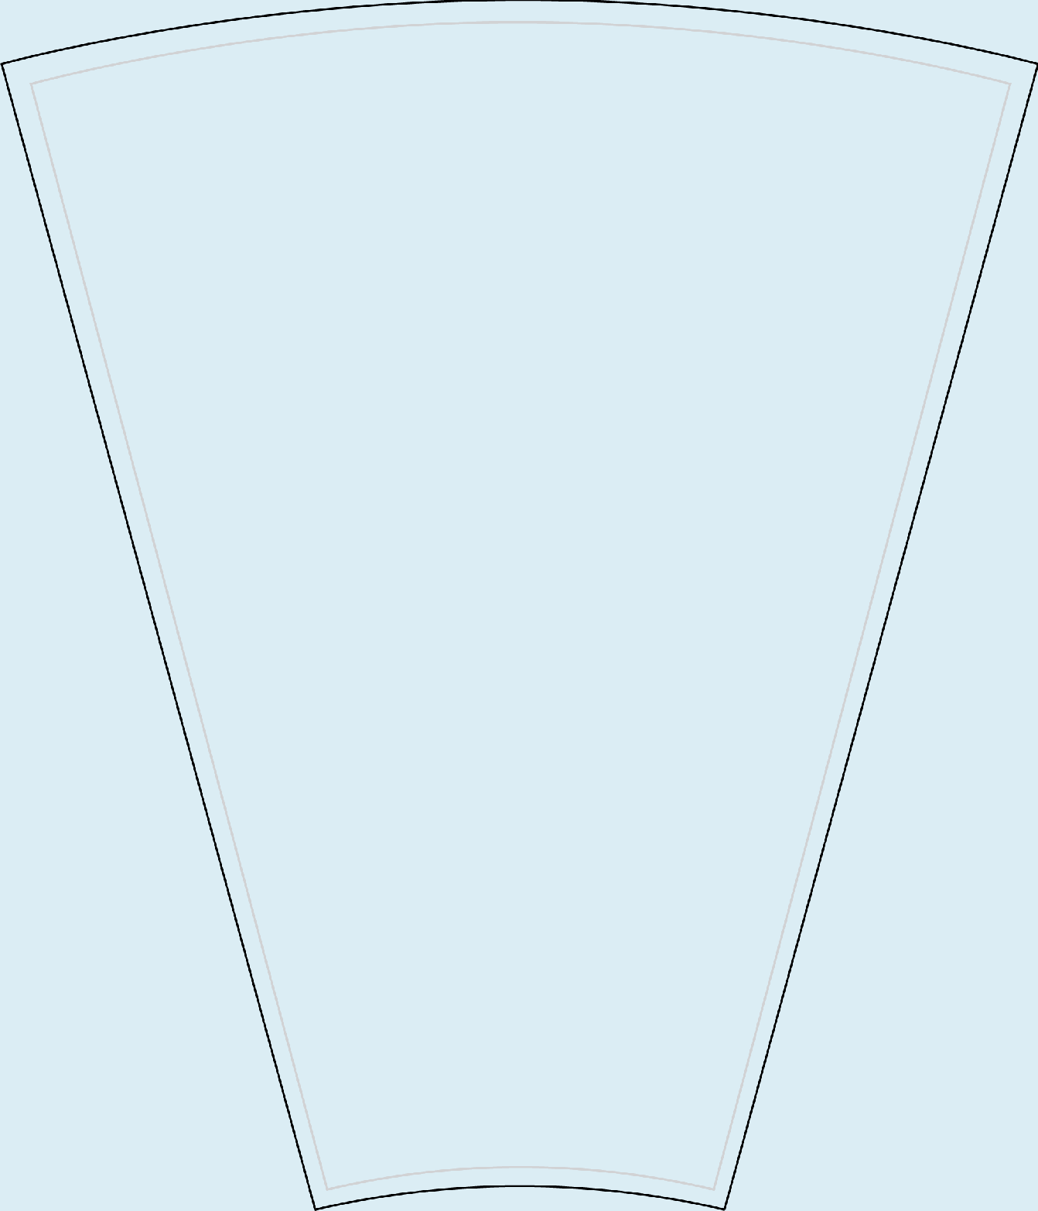
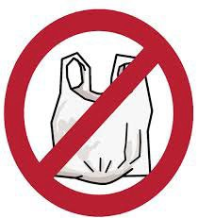
When does the plastic bag ban go into effect?

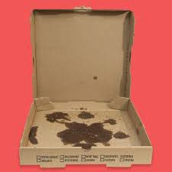
Can you recycle greasy pizza boxes?

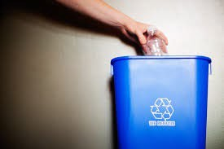
What # plastics should go into the recycling bin?

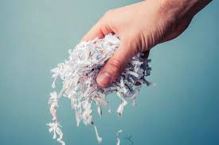
Can shredded paper be placed in your recycling bin?


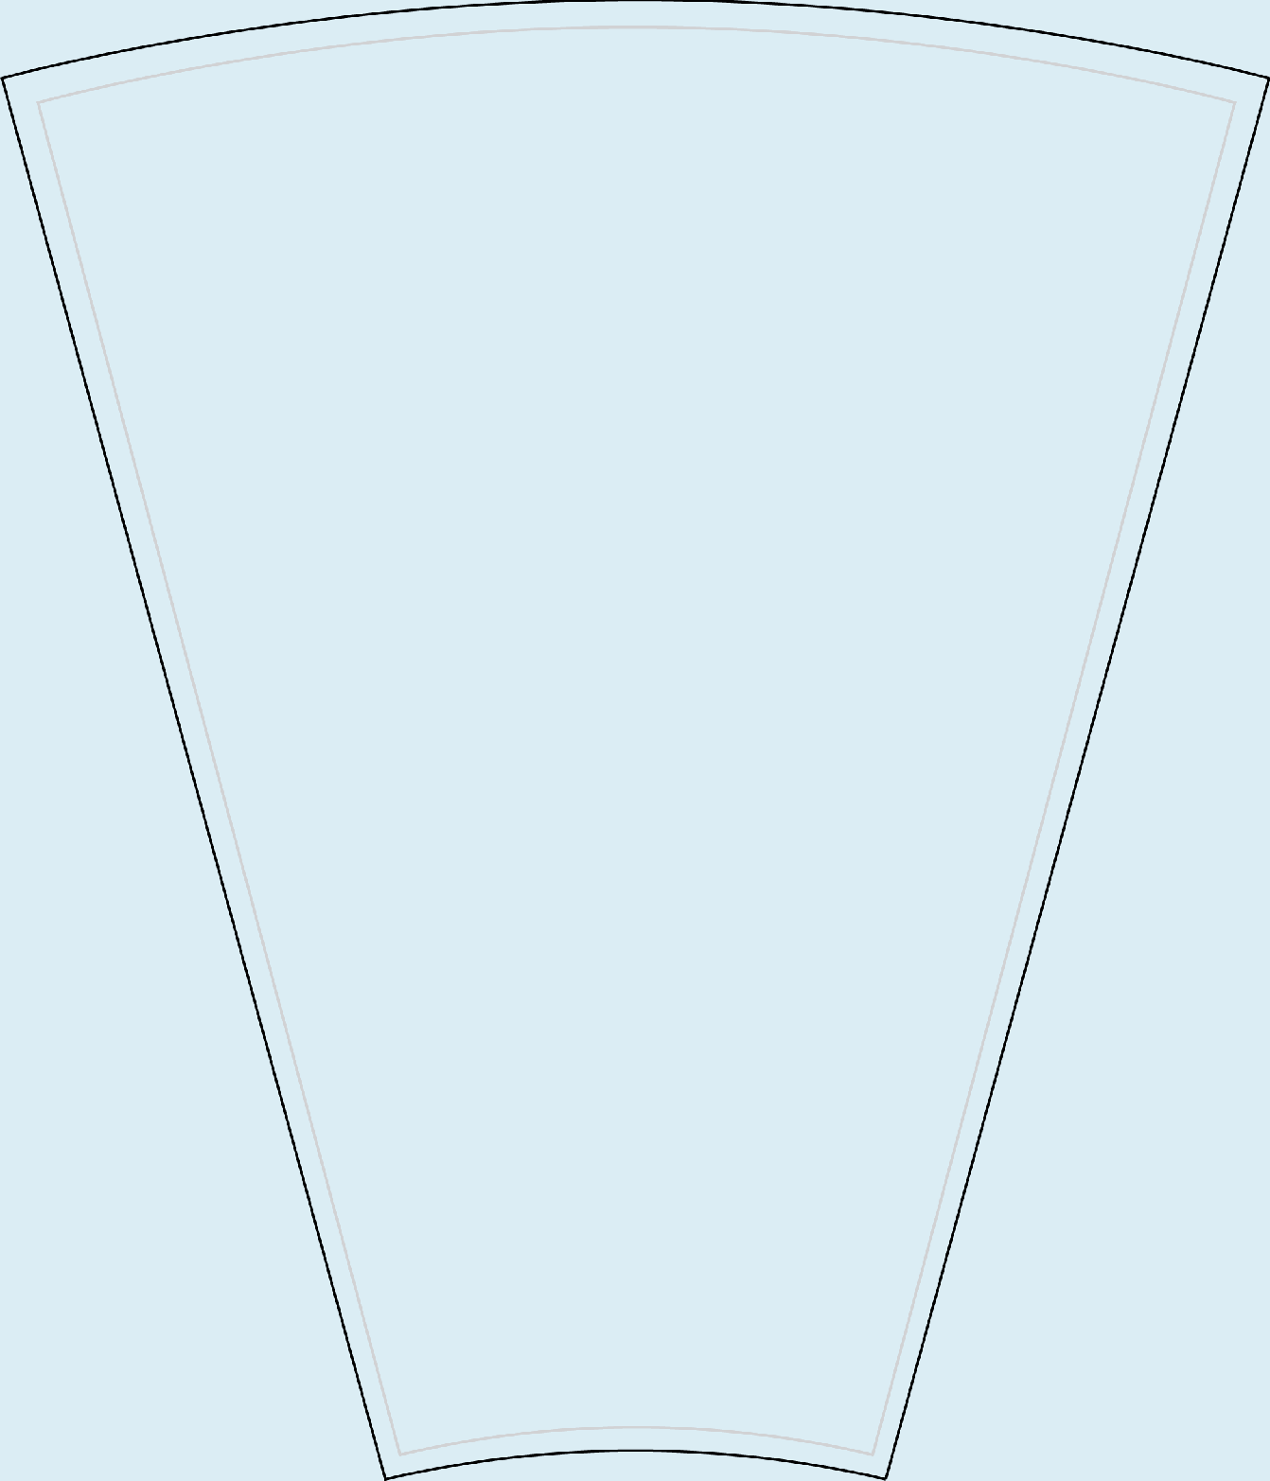
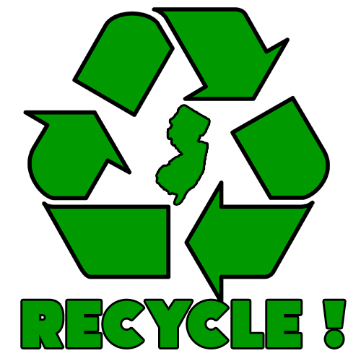
In New Jersey, who is supposed to recycle?

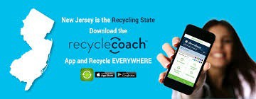
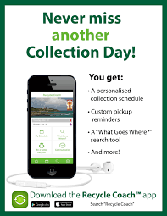
Do you know what Recycle Coach is?


What type of bag should you use while shopping?

What is one way in which you can choose to reuse?

True or False: Recycling means changing old materials into new products.

True or False:
100,000
marine animals are killed each year as a result of plastic bag pollution.


True or False: Paper towels go into the recycling bin.

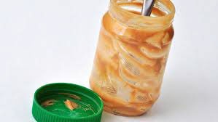
True or False:
This container is ready for recycling.

On average, how long is a plastic bag used by a person before being thrown away?

Plastic is made from which natural resource?
- Trees
- Metals
- Oil
- Sand

Recycling paper can save which natural resource?
  - Trees
  - Coal
  - Oil
  - Air

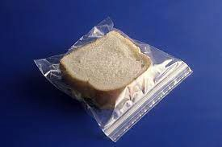
The average American family uses how many Ziploc bags a year?
    - 100
    - 250
    - 400
    - 500

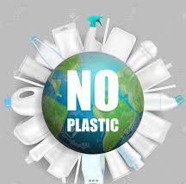
Enough plastic is thrown away each year to circle the Earth times?
A: 1
B: 2
C: 3
D: 4

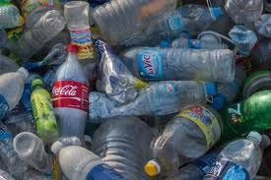
It takes one plastic bottle up to years to degrade in a landfill.
A: 200
B: 500
C: 1000
D: 1500

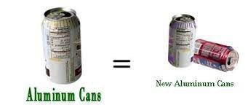
A used aluminum can can be recycled and back on the grocery shelf as a new can in as fast as days?
A: 60
B: 50
C: 40
D: 30

