
What does this
symbol mean?

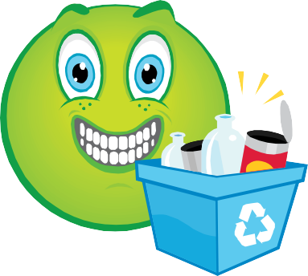
Name an item you can recycle.

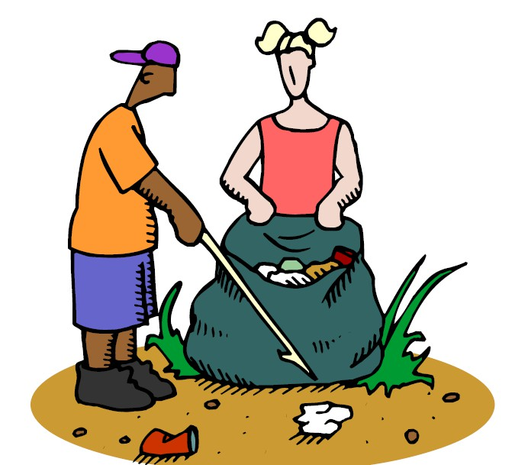
Throwing trash on the ground is called…..


What are the
three R’s?


Where should you put a candy wrapper?

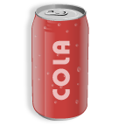
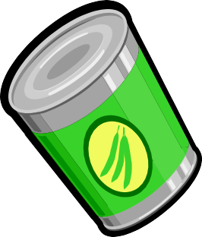
Do we recycle
metal cans?


Do we recycle
newspaper?


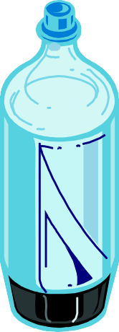
Do we recycle plastic bottles?

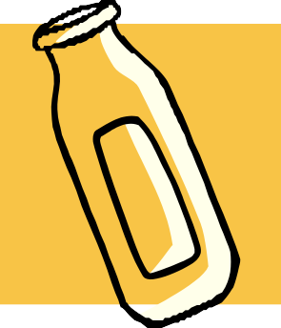
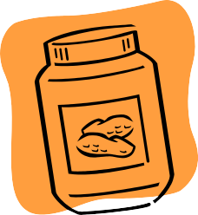
Do we
recycle glass jars and bottles?

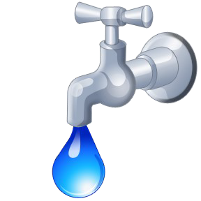
Save
by turning off the
faucet while you brush
your teeth.


Save
by turning off lights after you
leave a room.

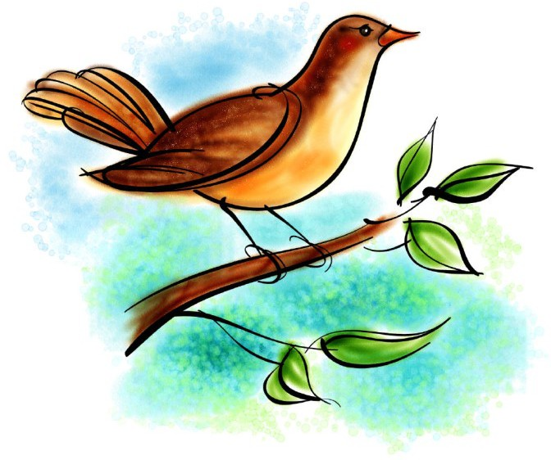
How can litter harm
animals?


Why are balloons
dangerous when
released?


Vermi- compost-
ing is
composting using
.

True or False You should recycle your paper
towels.




True or False We must
recycle at home and
in our schools.

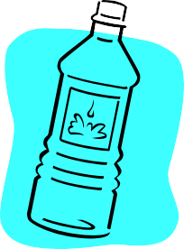
True or False Americans use
2.5 million plastic
bottles every
hour.


is using old vegetables,
fruit, and leaves to make a rich
amendment for plants.


True or False All plastic must be
recycled.

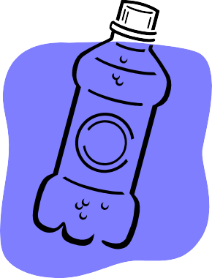
How long does it take a plastic
bottle to decompose?

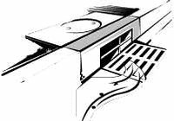
Is water that goes into a storm drain treated to
remove pollutants before going to the
ocean?





Name 3 items that must be recycled in Middlesex County.


True or False Using a mulching lawn mower is
good for your yard.

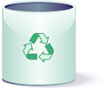
In New Jersey, who is supposed to
recycle?


True or False Everyone should recycle but it is
still voluntary.


What type of bags should you use
while shopping?

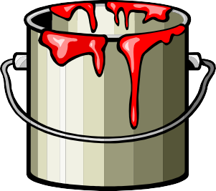
How do you dispose of old
oil-based paints?


A cigarette butt takes
10 weeks or
10 years to decompose?

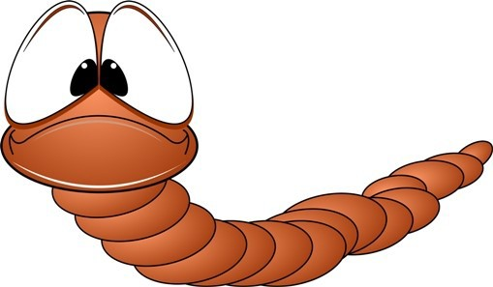
How long do red wiggler worms
live?

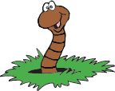
What types of worms are used in
vermi composting?

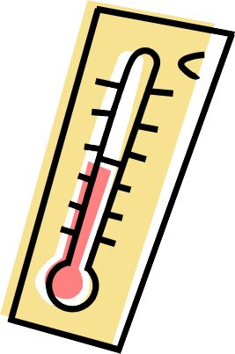
Can you keep your vermicompost bin
outdoors?

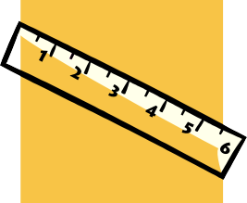
Vermicompost containers should be
inches deep.

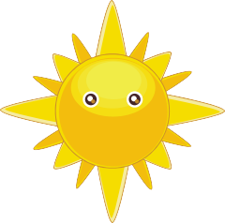


Do worms like to be in
the light or dark?


How many worms are in a pound of red
wigglers?


How many hearts does a
worm have?

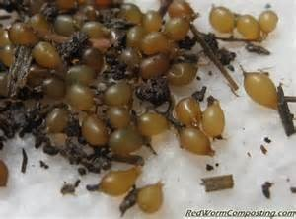
How many cocoons can a worm
make per week?

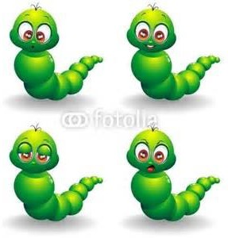
Each worm cocoon
produces
how many babies?

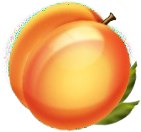
True or False - Don’t put sweet fruits
like peaches in your
vermi bin.


True or False - Worms eat half their weight
per day.


Preschool

- What does this symbol mean?
- Name an item you can recycle.
- Throwing trash on the ground is called .
- What are the three R’s?
- Where should you put a candy wrapper?
- Do we recycle cans?
- Do we recycle newspapers?
- Do we recycle plastic soda bottles? Do we recycle glass jars?

Elementary
- Save by turning off the faucet while you brush your teeth.
- Save by turning off lights after you leave a room.
- How can litter harm animals?
- Why are balloons dangerous when released?
- Vermicomposting is composting using .
- True or False - You should recycle your paper towels.
- True or False - We must recycle at home and in our schools.
True or False – Americans use 2.5 million plastic bottles every hour. (True)

Middle School
- is using old vegetables, fruit, leaves, and plant cuttings to make a rich food (soil) for plants.
- True or False - All plastic must be recycled. (False)
- How long does it take a plastic bottle to decompose? (450 - 500 years)
Is water that goes into a storm drain treated to remove pollutants before going to the ocean? (No) High School and up
- Name 3 items that must be recycled in Middlesex County.
- True or False Using a mulching lawn mower is good for your yard. (True)
- In New Jersey, who is supposed to recycle? (Everyone)
- True or False - Everyone should recycle but it is still voluntary. (False)
- What type of bags should you use while shopping? (canvas bags)
- How do you dispose of old oil-based paints? (Paint drop-off program or HHW event) A cigarette butt takes 10 weeks or 10 years to decompose? (10 years)
Vermi Questions
- How long do red wiggler worms live? (up to 10 years)
- What types of worms are used in vermicomposting? (Red Wiggler or brown nosed red wiggler)
- Can you keep your vermicompost bin outdoors? (Bins should be kept in a room with a temperature range of 55 - 77 degrees)
- Vermicompost containers should be inches deep. (12)
- Do worms like to be in the light or dark? (Dark)
- How many worms are in a pound of red wigglers? (~1000)
- How many hearts does a worm have? (5)
- How many cocoons can a worm make per week? (3 - 5)
- Each worm cocoon produces how many babies? (2-15)
- True or False - Don’t put sweet fruits like peaches in your vermi bin. (False - Red wigglers love sweet fruits)
- Worms eat half their weight per day. (True)

