In New Jersey, who is supposed to recycle?

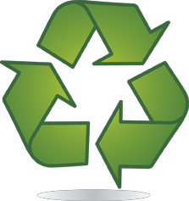

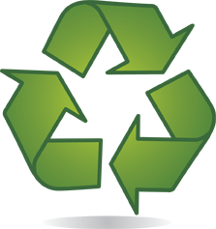
What does the word “recycle”
mean?

How long does it take for a plastic bottle to decompose?
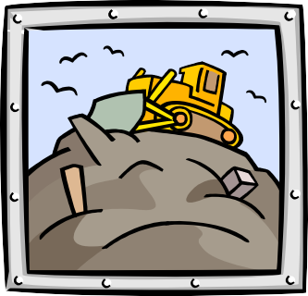

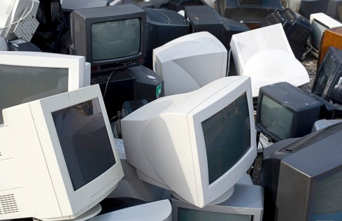
Name three Types of
Universal Waste

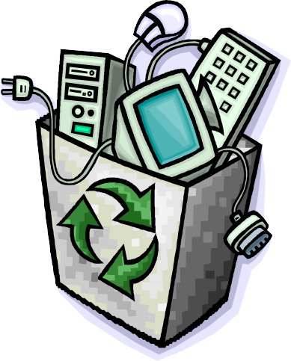
What is the best way to get rid of an old
computer?

What does the word “compost”
mean?
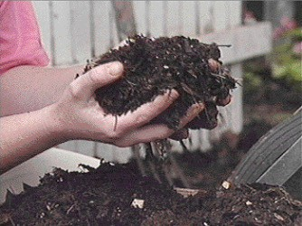

What # plastics are
recyclable?

What
does
biodegradable
mean?

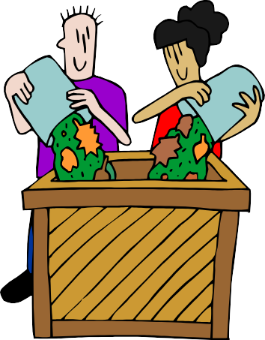

UC’s Resource Recovery Plant Generates what Renewable Resource ?

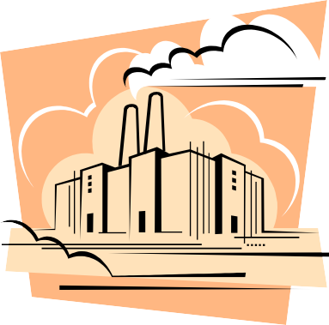

How long has recycling been mandatory
in NJ?

Why are we supposed
to recycle?

Name three Items that everyone
in Union
County should recycle?

When #1 & #2 plastic bottles
are empty, what should be done with
the bottle caps?

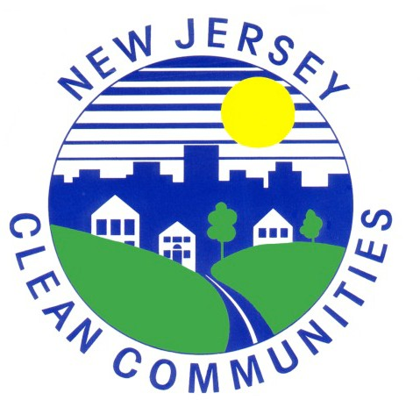
What is litter?

How can litter harm
animals?

