Balloon Litter and Release Bans
PreventBalloonLitter.org, “Inspirational, colorful, litter-free ideas to celebrate, to remember and to honor the people who impact our lives.” This site includes many alternative ideas for balloon releases and has good educational resources:
Factsheet and Publications
Balloon Mission Their mission is to collect balloons after people are finished using them, but before they end up as trash, causing harm to the environment, wildlife, and even us (from micro and nano-plastics). Balloon Mission’s motto, “Collect-Protect-Preserve,” aims to collect all foil and latex balloon pieces and ensure they’re safely disposed of so we can protect animals and preserve our ecosystems. Through their outreach programs, people are taking an active stand against plastic pollution, while still celebrating life’s moments
Terra Cycle Party Zero Waste Boxes
Joyful Sendoff The Joyful Send-off campaign encourages couples to use alternative, litter-free, send-off ideas that capture the same joyous and picture-perfect moment identified as one of the reasons balloon releases are conducted
Videos:
NJ Clean Communities Balloon Litter PSA
Balloon Litter: Say No To Letting It Go! (2:08 minutes, September 15, 2020)
Balloon Litter: A Conversation (3:28, September 2018)
Things to Know:
- There are only 10 States that passed the Ban on Balloon Release: California, Connecticut, Delaware, Florida, Hawaii, Maine, Maryland, Rhode Island, Tennessee, and Virginia.
- Fines range from no less than $100 up to no more than $500.
- The exception to this law is only a person on behalf of a governmental agency or pursuant to a governmental approved contract used for meteorological or scientific purposes. The other exceptions are hot air balloons that are recovered after being launched and balloons that are released indoors.
- The Sea Turtle Foundation estimates that 100,000 marine mammals and turtles and 1 million sea birds die every year from ingesting or becoming entangled in balloon debris.
- There is evidence to suggest that micro-plastics are becoming so tiny that even oysters are able to consume them.
- Metallic coating on Mylar Balloons can cause power outages and or fire when the balloon comes in contact with the electrical lines.
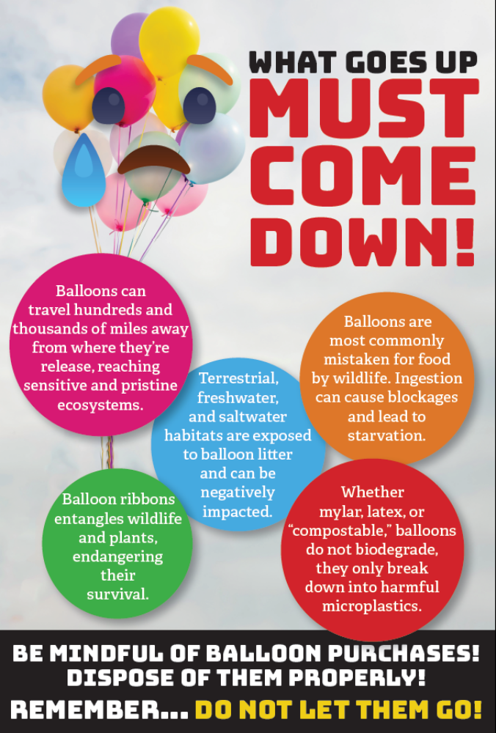
Balloon Release Bans
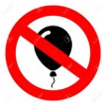
Sample Ordinances for Banning Balloon Releases:
- Atlantic City - Ordinance
- Hammonton - Ordinance
- Longport - Ordinance
- New Milford - Ordinance
- North Wildwood - Ordinance
