Plastic Straws
To reduce litter, NJ Law mandates that as of November 4, 2021, plastic straws can only be provided upon request. See New Jersey’s “Skip the Straw” educational campaign. For more Skip the Straw resources, visit Litter Free NJ’s website

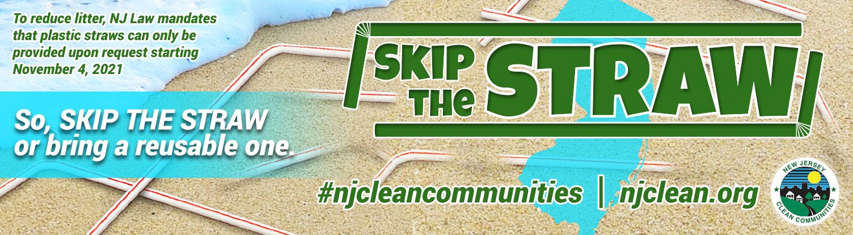

Skip the Straw PSA: https://www.youtube.com/shorts/Z7vclyepeCA?feature=share
Visit the NJDEP’s site Get Past Plastic regarding the plastic straw legislation and other single-use plastics legislation.
Other Campaigns and Websites from Across the Country Targeting Plastic Straws
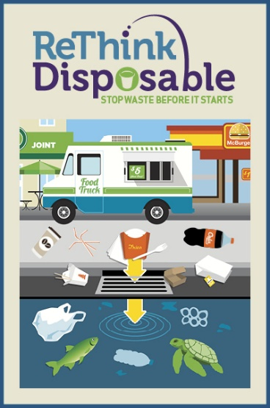
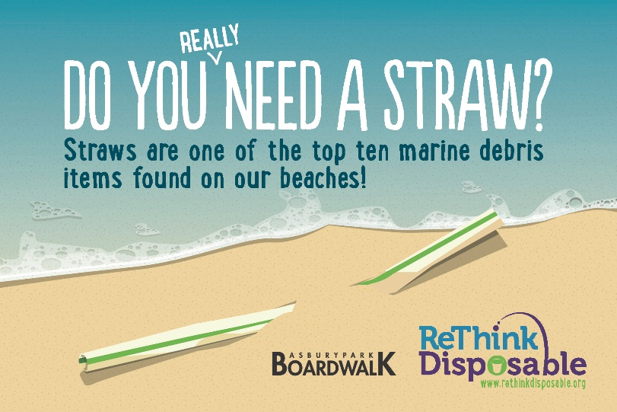
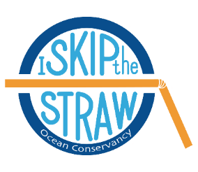
Just Say No to Straws blog from Clean Water Action, May 24, 2017,
part of their Rethink Disposable in NJ campaign along with this video (1:48 minutes)

Skip the Straw from Ocean Conservancy

