Stormwater Education Examples
Clean Water NJ (NJDEP) – Offers many educational resources to download for free (video ads, radio ads, flyers, brochures)
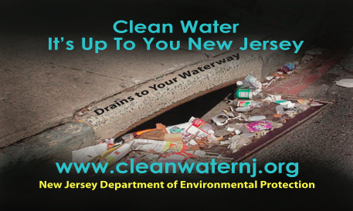

Solutions to Stormwater Pollution – stormwater education & outreach
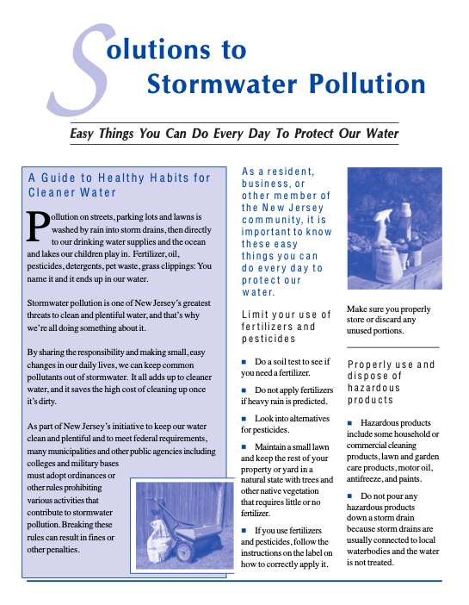

Sample Educational Materials from Counties and Towns:
Galloway Township:
Link to all flyers/brochures/graphics
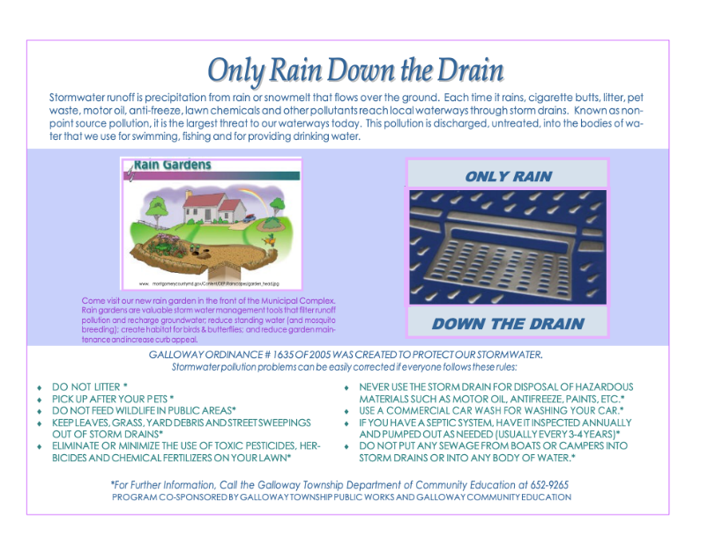
Fair Lawn Borough Storm Drain Litter
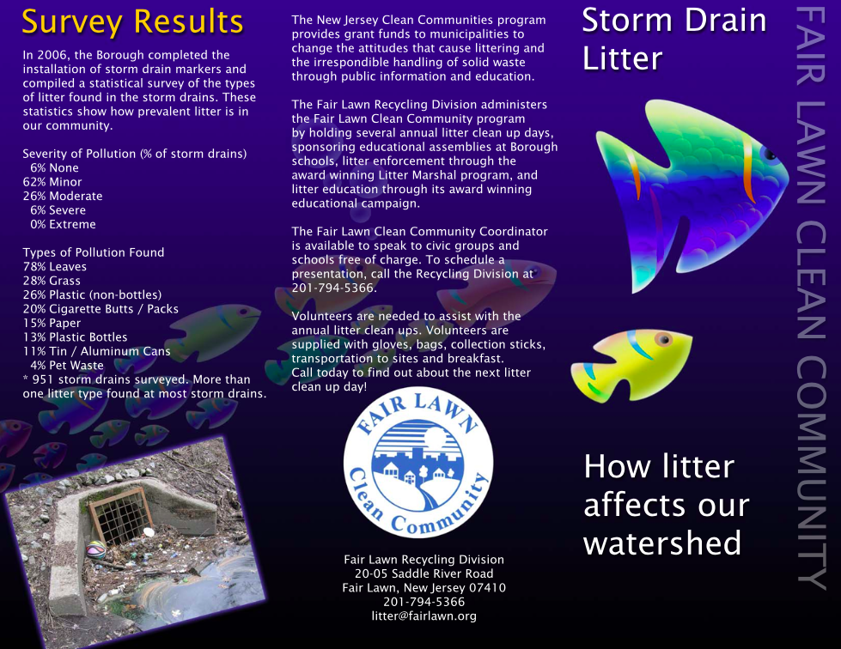

Storm Drains
See also NJCC Best Practices Storm Drain Section under Education
Storm Drain Labeling Guidelines for New Jersey (17 pages, March 2004) prepared by NJDEP, Division of Watershed Management
“Storm drain labeling is a great way to make people in your community more aware of nonpoint source pollution and polluted runoff.”
“Storm drain labeling serves as an educational tool to remind people about the connection between storm drains and local waterbodies.”
“Storm drain inlet labeling is also a requirement of New Jersey’s new municipal stormwater permitting program.”

