Watershed Information
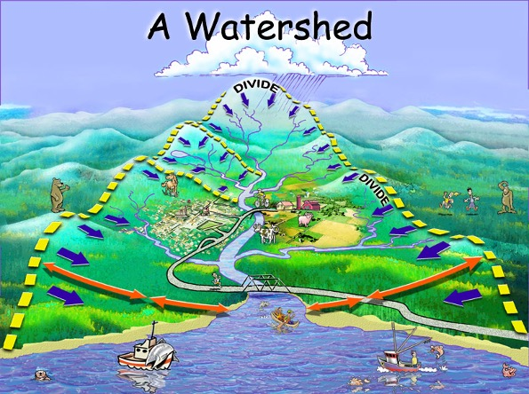
A watershed is an area of land that drains into a body of water such as a river, lake, stream, or bay. It is separated from other watersheds by high points in the areas such as hills or slopes. It includes not only the waterway itself but also the entire land area that drains to it. For example, the watershed of a lake would include not only the streams entering that lake but also the land area that drains into those streams and eventually the lake. Drainage basins generally refer to large watersheds that encompass the watersheds of many smaller rivers and streams.
No matter where you are in New Jersey, you are in a watershed. Watersheds are everywhere from your front doorstep to the local park to the shopping mall to the creek down the road. Watersheds are the link between our land, our water and our communities because the quality of our water is linked to how we use the watershed surrounding it.
To learn more about watersheds please visit the NJDEP Watershed Restoration site
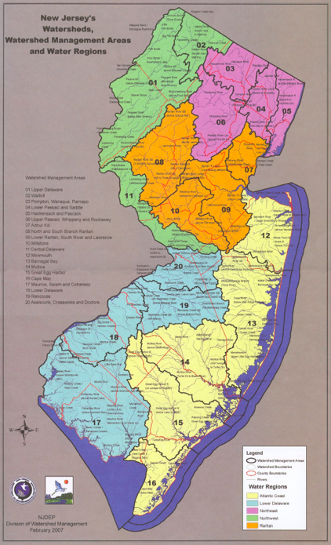
New Jersey has five watershed regions:
- Atlantic Coastal
- Lower Delaware
- Northeast
- Northwest
- Raritan
New Jersey has 20 watershed management areas:
01 Upper Delaware
02 Wallkill
03 Pompton, Pequannock, Wanaque, Ramapo
04 Lower Passaic, Saddle
05 Hackensack, Hudson, Pascack
06 Upper and Mid Passaic, Whippany and Rockaway
07 Arthur Kill
08 North and South Branch Raritan
09 Lower Raritan, South River, and Lawrence
10 Millstone
11 Central Delaware
12 Monmouth
13 Barnegat Bay
14 Mullica
15 Great Egg Harbor
16 Cape May
17 Maurice, Salem and Cohansey
18 Lower Delaware
19 Rancocas
20 Assiscunk, Crosswicks and Doctors

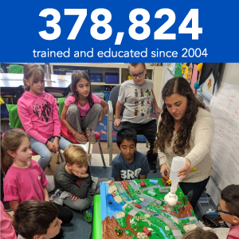

Watershed Ambassadors
“The New Jersey Watershed Ambassador Program is a community-oriented AmeriCorps program designed to raise awareness about water issues in New Jersey. Through this program, Watershed Ambassadors are placed at local host sites in twenty (20) Watershed Management Areas (WMAs) from Sussex to Cape May counties to serve their local communities. Three Source Water Protection (SWP) Ambassadors are placed in north, central, and south locations and will engage in outreach and education campaigns that will lead to the protection of drinking water sources. The program works with all sectors of society to improve the quality of New Jersey’s waterways, nurturing community-based environmental activities and empowering residents to make responsible and informed decisions regarding their watershed. Watershed Ambassadors are available to make FREE environmental education presentations to community organizations and schools.”
Find Your Watershed Ambassador
Watershed Ambassador Flyer

