Cigarette Butts – Overview and Litter Data
Cigarette butts account for approximately one in every five items collected during beach cleanups. Often littered on our sidewalks and streets, they end up in our storm drains, flowing to our streams, rivers, bays, lagoons and ultimately the ocean. An estimated 4.95 trillion cigarette butts are disposed of in our environment annually worldwide. Litter clean-up costs the U.S. over 11 billion annually, cigarette butts represent an estimated 32% of that litter.
In the 2020 Keep America Beautiful National Litter Study, 9 out of 10 littered items counted were 4″ and less, with cigarette butts being the number one littered item in this category, accounting for 9.7 billion butts counted on any given day in the United States.
Smokers can easily - and happily - dispose of their butts in appropriate ash receptacles instead of tossing them out car windows or on the ground. The problem is that most smokers do not even think that their actions in tossing a butt to the ground is littering - it's just how they have always disposed of the cigarette. Once awareness is raised, most smokers are caring and considerate enough to change their conduct. Raising awareness is the biggest key to resolving this problem.
Cigarette Butt Facts:
- Cigarette litter has been the most littered item recovered every year during the International Coastal Cleanup by more than two to one.
- Cigarettes are littered on average 142 times per second.
- Cigarette butts made up 38 percent of all roadside litter and representing 28 percent of all debris collected.
- Eighty percent of the 4,500,000,000 (!) butts littered annually worldwide find their way into water systems, causing a deterioration of overall quality.
- The cigarettes littered worldwide in one year alone can go from the moon to the earth almost 300 times.
- Littered cigarettes are responsible for destructive fires that have caused vast amounts of property damage and wreaked havoc on many lives.
- Property maintenance costs are greatly reduced by reducing cigarette litter.
- They are the number one littered item on US roadways and the number one item found on beaches and in waterways worldwide.
- Cigarette butts are composed of cellulose acetate, a non-biodegradable plastic, which can take up to 25 years to decompose.

How to Make a Difference:
- Install outdoor ash cans (which can result in a 65% reduction in cigarette butt litter)
- Distribute pocket ashtrays to smokers
- Promote education and community awareness
- Introduce stronger laws/enforcement of cigarette litter laws
- Ensure restaurants/bars provide outdoor receptacles

Smoking Bans and Cigarette Butt Litter
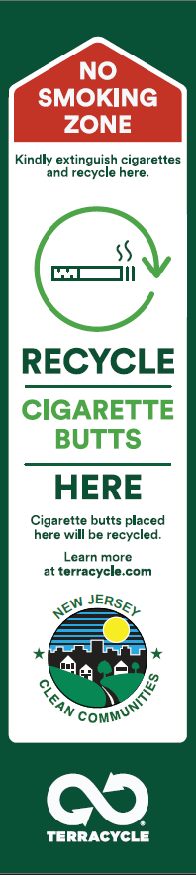
Litter-free initiatives and smoking bans can successfully coexist when paired with the right infrastructure! While smoking bans help limit exposure to secondhand smoke and promote healthier public spaces, designated smoking receptacles ensure that cigarette waste is properly managed. Without disposal options, smokers may be more likely to discard cigarette butts improperly, creating litter and environmental hazards. By providing clearly marked containers in strategic areas, communities can uphold clean and safe environments, reduce fire risks, and support both public health goals and responsible waste management.
Here is a graphic from Terracycle that can be used for cigarette recycling receptacles outside of No Smoking zones.

Links to Helpful Information:
- Ash Receptacles and Portable Ashtrays
  - Butt Buckets (portable auto and boat ashtray)
  - Pocket Ashtrays
- From COA (Clean Ocean Action): Ten Tips for Smokers
- From NAMEPA (North American Marine Environment Protection Association): Keep your butt’s OFF the beach!
  - Sign up to download free educational material from NAMEPA here.
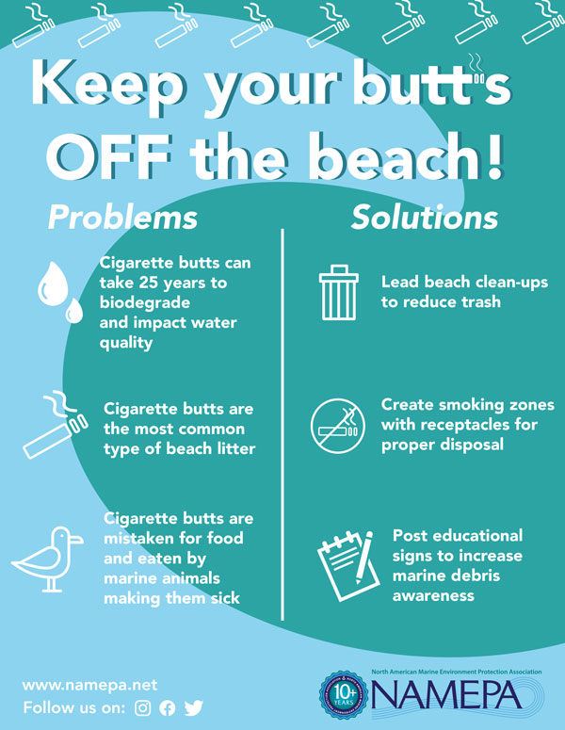

KAB (Keep America Beautiful): Cigarette Litter Prevention Program
  - Grants:
    - KAB provides Cigarette Litter Prevention and Cigarette Litter Collection Stand grants through their Community Grants program
    - Additionally, Boat U.S. Foundation (Boat Owners Association of the U.S.) in partnership with KAB runs a Cigarette Litter Prevention grant program for marinas to supply $500 grants to purchase receptacles, signs and portable ash trays for use on boats.
    - Terracycle is proud to offer a 100% rust-resistant aluminum Cigarette Waste Receptacle that allows an easy and accessible solution for recycling cigarette butts. The TerraCycle Receptacles can be attached in community locations, outside of your business or workplace, or in designated smoking areas to reduce unsightly cigarette butts from littering your premise. All cigarettes collected can be sent to TerraCycle to get recycled for free through TerraCycle’s Cigarette Waste Free Recycling Program.
  - Other Resources :
    - Cigarette Litter in America, Infographic (1 page, 2017)
    - Smoking Bans and Cigarette Litter at Transition Points, Report (48 pages, Dec 2020)
    - Findings from a study of Smoking Bans and Cigarette Litter at Transition Points, Report Summary (3 pages, Dec 2020)
