Fishing Line (Monofilament) Receptacles
Fishing line can be an especially dangerous form of litter because of its potential harm to marine life. According to the USEPA’s Aquatic Trash Prevention Nation Great Practices Compendium (December 2016), the “Reel In and Recycle Program”, a nationwide monofilament fishing line recycling program, was created and initiated in 2006 by the BoatU.S. Foundation. In five years, the program established a network of over 2,000 monofilament recycling bins distributed and installed at over 700 locations across the country.
For program details, visit these links:
BoatU.S. Foundation’s Clean Boating Programs
Reel In & Recycle Program for fishing line collection and recycling
How to Build a Monofilament Recycling Bin video (3:01 minutes)
Order signs and decals
Reel n and Recycle Sign from BoatU.S.
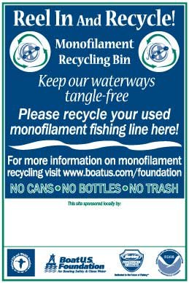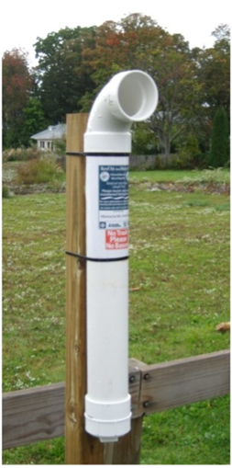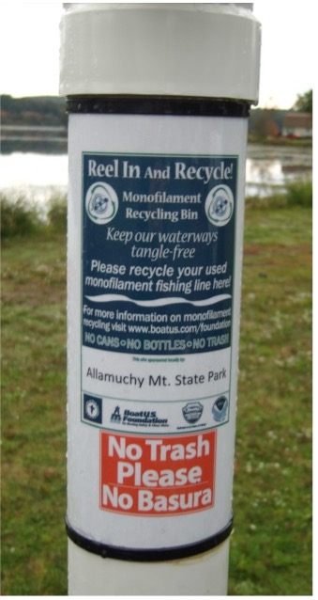

Morris County Fishing Line Program

Monofilament Fishing Line Recycling Program by Surfrider Foundation South Jersey
Surfrider Foundation South Jersey’s Monofilament Fishing Line Recycling Program is underway, with the support and partnership of TackleDirect. Surfrider Foundation South Jersey volunteers build monofilament recycling receptacles to be installed at popular fishing locations and launching ramps, where fishermen can discard their unwanted monofilament line.
COA (Clean Ocean Action) also has these two helpful lists of tips for anglers and boaters:
- Ten Tips for Anglers

