Microplastics

What are microplastics and where do they come from?
Microplastics are small plastic pieces or fibers that are between 1 nanometer and 5 millimeters in size. They come in many forms including beads, fragments, pellets, fibers, and more.

According to the International Union for Conservation of Nature, sources of microplastics include textiles (including clothing), tires, dust, and plastic products.

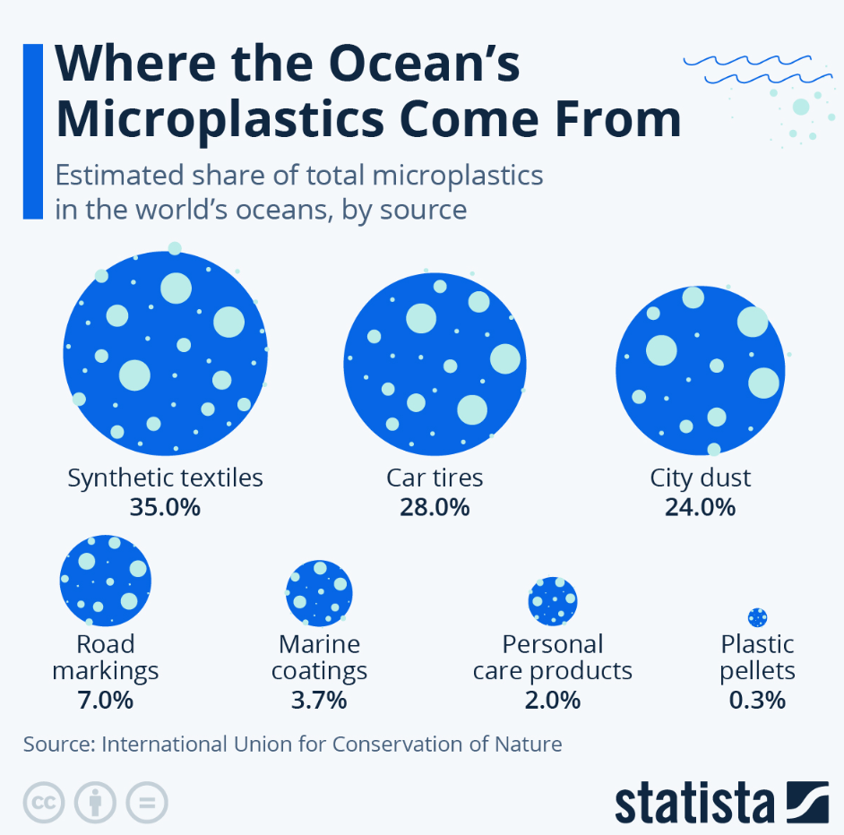

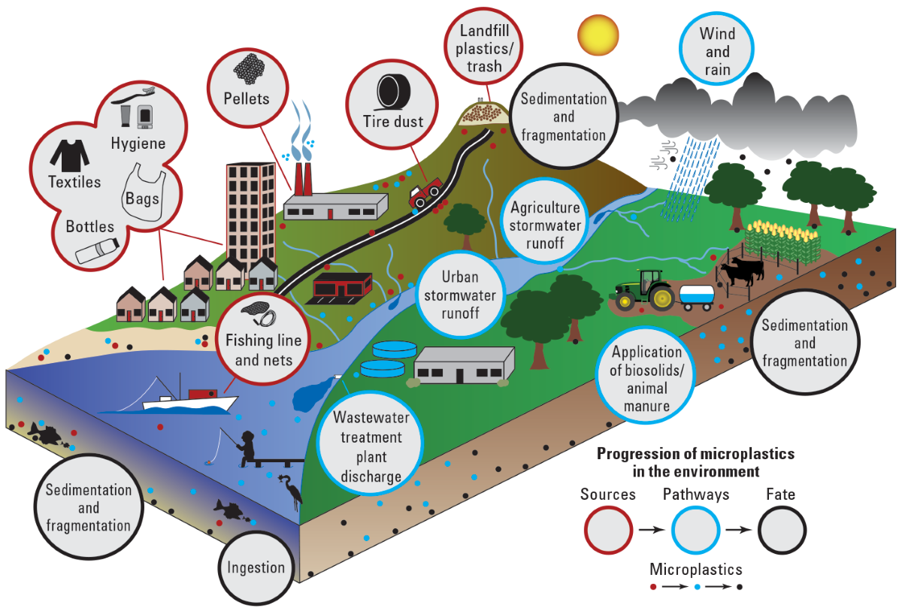
Graphic from Jeffrey L. Corbett, USGS

How are they harmful?
Wildlife can mistake microplastics for food, which can transfer up the food chain to humans. In fact, microplastics have been found in human blood and breastmilk. There have been studies showing that microplastics and chemicals in the plastics may impact the gene expression, development and behavior of numerous organisms including humans.

How can I reduce the generation of microplastics?
Here are a few ideas:
- Reduce microfiber pollution from your washing machine by
  - Washing clothes less often
  - Washing in cold water
  - Using the gentle cycle
  - Installing a microfiber filter
- Don’t litter! Participate in your local litter clean-up events.
- Say no to single-use plastics like utensils and pre-filled water bottles.
- Choose items with plastic-free packaging such as shampoo/conditioner/soap bars and toothpaste tablets.
- Say no to “fast fashion”
- Reduce tire wear by maintaining the correct tire pressure, avoiding sharp breaking or accelerating and driving less.
- Properly recycle your plastic bottles, jars, jugs and tubs according to your local recycling program.

Sources and links to more detailed information:
- National Oceanic and Atmosphere Administration Microplastics Website https://marinedebris.noaa.gov/what-marine-debris/microplastics
- Microplastics Marine Debris Fact Sheet from the National Oceanic and Atmosphere Administration https://marinedebris.noaa.gov/fact-sheets/microplastic-marine-debris-fact-sheet
- National Oceanic and Atmosphere Administration Interagency Marine Debris Coordinating Committee Report on Microfiber Pollution https://marinedebris.noaa.gov/interagency-marine-debris-coordinating-committee-reports/interagency-marine-debris-coordinating-committee-report-microfiber-pollution
- USEPA Trash Free Waters Website with information on aquatic trash and hos it can be prevented https://www.epa.gov/trash-free-waters
- USGS - Microplastics Sources, Pathways and Fate Conceptual Diagram https://www.usgs.gov/index.php/media/images/microplastics-sources-pathways-and-fate-conceptual-diagram
- “Where the Ocean’s Microplastics Come From” Infographic https://cdn.statcdn.com/Infographic/images/normal/17957.jpeg
- NJDEP Science Advisory Board Final Report - Microplastics In The Aquatic Environment: Sources, Occurrences, And Currently Known Risks https://dep.nj.gov/wp-content/uploads/sab/sab-microplastics.pdf
- OCEAN WISE Smart Wash Cycle Report https://ocean.org/app/uploads/2022/12/OceanWise-WashingReport.pdf
- International Union for Conservation of Nature – Primary Microplastics in the Oceans: A Global Evaluation of Sources, January 2017 https://www.iucn.org/
- Illinois EPA – Microplastics Website https://epa.illinois.gov/topics/water-quality/microplastics.html
- USEPA – Research on Environmental and Health Impacts of Tires https://www.epa.gov/sciencematters/where-rubber-meets-road-epa-researchers-study-environmental-and-health-impacts-tires
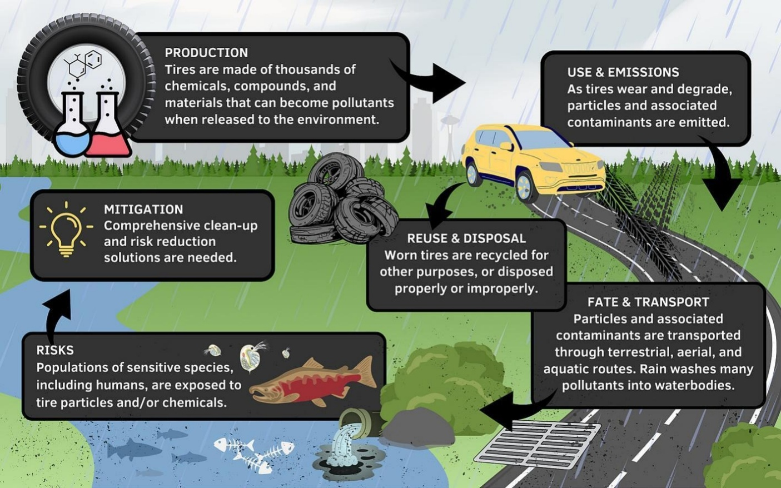
Graphic link: https://ars.els-cdn.com/content/image/1-s2.0-S0048969724012920-ga1_lrg.jpg

- World Economic Forum – Article on tires and microplastics https://www.weforum.org/agenda/2023/08/tyre-wear-microplastics-pollution/

