PET WASTE
NJ Clean Communities Pet Waste Reel — Easily Shareable on Social Media (available on LitterFreeNJ.com
COA (Clean Ocean Action) has these two helpful lists of tips for pet owners:
- Ten Tips for Cat Owners
- Ten Tips for Dog Owners
Here are two versions of this pet waste infographic message from the NJDEP Clean Water NJ Program:
- Poster link (Man with Dog)
- Customizable Flyer link (Clean Water)
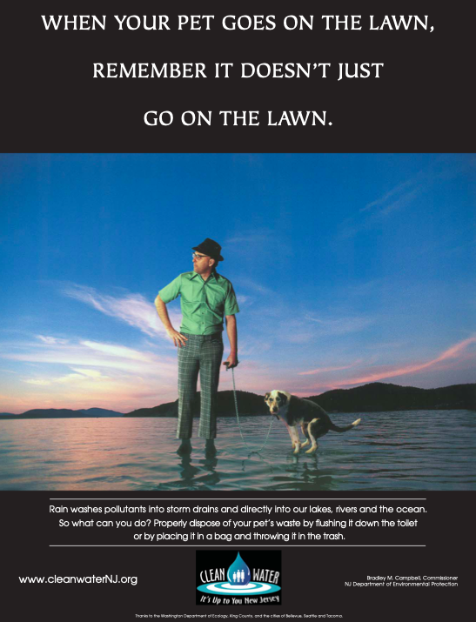

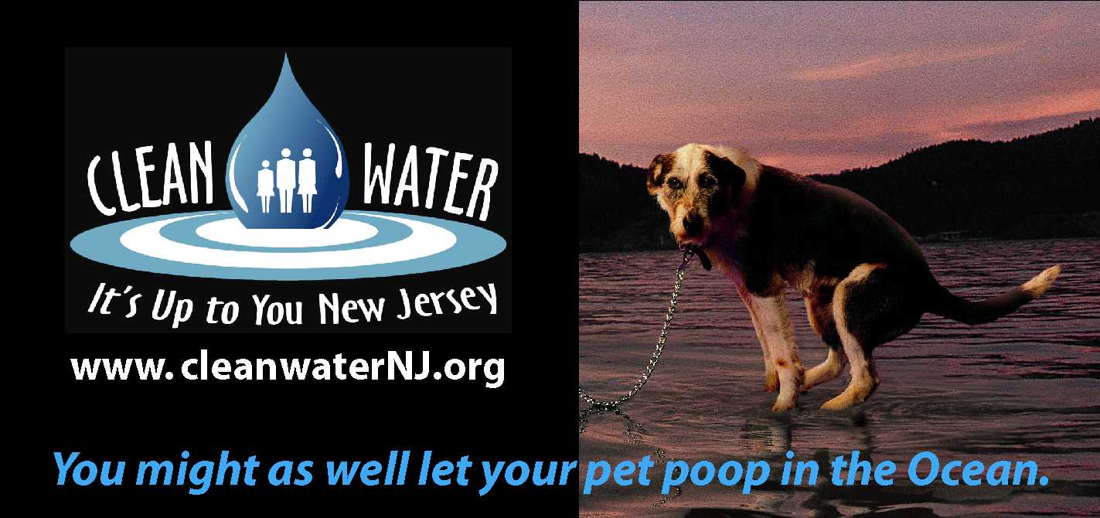

Here are two other informative webpages on pet waste from:
- Montgomery County, Maryland
- Frederick County, Maryland
